2.2 Subtracting integers

The temperature was 12°C at 1 pm. By midnight it had dropped to –3°C.
What is the difference between these temperatures?
To calculate a difference we subtract: 12 – (–3).
To subtract positive and negative numbers, refer to a number line.
To subtract a positive number, move to the left.
To subtract a negative number, do the opposite: move to the right.
We can replace – – with +.
–3 – 5To subtract 5 from –3, start at –3 on the number line.
Count 5 places to the left (in the negative direction).

The answer is –8, so –3 – 5 = –8
4 + (–2)To subtract –2 from 4, start at 4 on the number line.
Count 2 places to the right (the opposite of the negative direction).

The answer is 6, so 4 – (–2) = 6
EXAMPLES

1 Complete these subtractions.
You can use the number line at the top of this page to help.
a 6 – 2 = ______________ b 10 – 7 = ___________ c 8 – 3 = ___________
d 4 – 9 = ______________ e 3 – 6 = ____________ f 0 – 5 = ___________
g –5 – 2 = _____________ h –4 – 4 = ___________ i –6 – 0 = __________
j 4 – 6 = ______________ k 2 – 9 = ____________ l –4 – 7 = __________
m 5 – (–2) = ____________ n 4 – (–3) = __________ o –1 – (–5) = ________
p –6 – (–4) = ___________ q 7 – (–5) = __________ r –3 – (–9) = ________
s –5 – (–8) = ___________ t –8 – 4 = ___________ u –8 – (–5) = ________
v –9 – (–9) = ___________ w 9 – 12 = ___________ x –7 – (–11) = _______
2.2 Subtracting integers
continued
2 The temperature on a day in winter reached a maximum of 12°C.
It dropped down to –3°C overnight.
How many degrees did the temperature drop? _____________
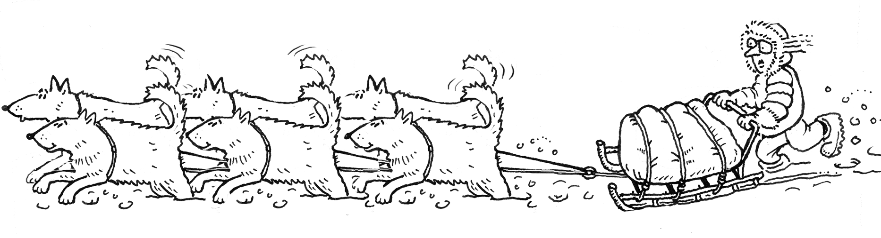
3 The daytime temperature in Stockholm was –2°C.
The next night, the temperature dropped 7 degrees.
What was the temperature that night? _____________
4 On a winter’s day in Moscow, the maximum temperature was –4°C.
The lowest temperature overnight was –21°C.
What is the difference between these temperatures? ______________
5 The time in Auckland (New Zealand) is 2 hours ahead of the time in Melbourne.
The time in Bangkok (Thailand) is 3 hours behind Melbourne time.
What is the time difference between Auckland and Bangkok? ____________
6 The table compares the local time in these cities with Australian Eastern Standard Time (AEST). AEST is the time in the eastern states of Australia.
City | Hours difference  from AEST
Bangkok | –3
London | –10
New York | –15
a What is the time difference
between London and Bangkok? ___________
b What is the time difference
between Bangkok and New York? _________
7 The summit of Mount Kosciuszko is the highest point in Australia.
It is 2 230 metres above sea level.
Death Valley in California, USA, is 86 metres below sea level.
What is the difference in altitude between these two points?
(Altitude refers to the height above or below sea level.) ____________
8 The highest point on Earth is Mount Everest (8 840 metres above sea level).
The lowest point on land is the Dead Sea in the Jordan Valley
(397 metres below sea level).
What is the difference in altitude between these two points? ____________

